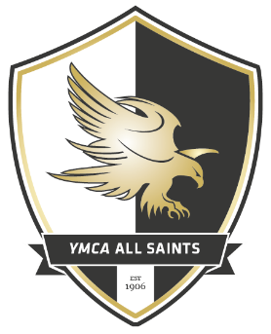

YMCA All Saints contact list
Name | Role/Team | Contact number | E mail address
Vic Hibbert | Chairman | 07724242839 | vichibbert@gmail.com
Chris Sheeran | Vice Chairman | 07525140674 | sheerancp@hotmail.co.uk
Wayne Jogo | Secretary | 07528780671 | waynejago@hotmail.co.uk
Rob Leppard | Treasurer | 07952833191 | robleppard68@gmail.com
Stacey Ferris | Welfare & Covid Officer | 07761963132 | Stacey.f@ymcaplymouth.org.uk
Andrew Kane | U11s Head Coach | 07395748667 | Andrewkane22@gmail,com
Barry Sellers | Head Coach | 07595416535 | Barry.s@ymcaplymouth.org.uk

